Sub ConslidateWorkbooks()

Path = ""

Filename = Dir(Path & "\*.xls")

Do While Filename <> ""

Workbooks.Open Filename:=Path & Filename, ReadOnly:=True

For Each Sheet In ActiveWorkbook.Sheets

Sheet.Copy After:=ThisWorkbook.Sheets(1)

Next Sheet

Workbooks(Filename).Close

Filename = Dir()

Loop

End Sub

**TASK1**

**Task 1: Project Understanding**

First up, why has Accenture built this program?

The recruitment team at Accenture has created this program to educate and identify great candidates.

If you aren’t yet ready to apply to us, that’s okay! This program will help you to explore what the job involves and build your resume.

So, how do you benefit?

1. You get relevant work experience taught by our team
2. Add the program as a Certification to your Resume and LinkedIn
3. Stand out in applications and interviews - talk about the job skills you've learned and why you're a good fit for the team.

And what does the Accenture Team see?

We have access to a dashboard to see who joins and completes our programs, and to contact you about upcoming opportunities - (only if you share your data with us of course!).

By completing the program, you're showing us that you're a motivated student who's interested in Accenture, this is very important to us. Don't worry, this is not an assessment tool, this is a safe learning environment for you to build your skills.

**Before we begin…**

Here are some key facts about this program:

* You are working as a Data Analyst at Accenture.
* You work within a larger team, where each member has a different role and level of responsibility.
* Your team has been assigned a new project for a client called **Social Buzz.**
* You’re hoping for a promotion at work, and this is an exciting opportunity for you to showcase your data analysis and visualization skills.

Let's get started!

**Key roles and responsibilities of a Data Analyst**

A data analyst sits between the **business** and the **data.**

What do we mean by that?

* **The Business** refers to the client and your internal team members who won’t be involved in detailed data analysis.
  + They rely on your analysis to make strategic business decisions.
  + Importantly, not everyone will have a strong understanding of data. Your job is to communicate your data findings simply and clearly for everyone to understand.
* **The Data** refers to the relevant data sources that you will clean, process, and use to generate interesting insights for the business.

As a Data Analyst at Accenture, you’ll get to work across a range of different clients and projects. This keeps things interesting, as there are always new problems to solve and new topics to learn about.

However, our clients often want accurate results in a tight timeframe. The pace of work is fast and you’ll need to get up to speed on new projects as quickly as possible.

Now you know a bit more about the role, let’s get back to the project with Social Buzz.

**Read the brief from Social Buzz**

**Your first task is to read the brief from Social Buzz and complete a short knowledge check before the call.**

One of Accenture’s Managing Directors, Mae Mulligan, is the client lead for Social Buzz.

She has reviewed the brief provided by Social Buzz and has assembled a diverse team of Accenture experts to deliver the project.

Mae has scheduled a project kick off call with the internal Accenture project team for tomorrow morning.

Ahead of the call, Mae has shared the project brief so you can get up to speed on what Social Buzz need help with.

Read the brief to:

* Understand the client and business problem at hand.
* Identify the requirements that need to be delivered for this project.
* Identify which tasks you should focus on as a Data Analyst.

Complete the knowledge check to move onto the next step. You can attempt each question in the knowledge check as many times as you like!

LINK : Data Analysis Client Brief

**Here are some resources to help you**

**Here are some key terms if you're curious:**

Note: You don’t need to know anything more about Big Data or IPOs for this program.

**Big Data** refers to large, diverse sets of information that grow at ever-increasing rates. It includes the volume of information, the velocity or speed at which it is created and collected, and the variety or scope of the data points being covered (known as the "three v's" of big data). Source: [Investopedia](https://www.investopedia.com/financial-edge/0312/ipos-for-beginners.aspx" \t "_blank).

An **IPO** stands for Initial Public Offering - this happens when a private company becomes public by selling its shares on a stock exchange. Source: [Investopedia](https://www.investopedia.com/terms/b/big-data.asp" \t "_blank).

**Question 1 of 2**

**Which statement best describes the business problem that Accenture is tasked to address for this project?**

* The clients financial stability has rapidly declined due to COVID-19 and they need to find new market opportunities to increase revenue.
* The client is looking to raise a significant amount of money through private investment and needs support with this.
* The client has reached a massive scale within recent years and does not have the resources internally to handle it.
* The client has reached a massive scale within recent years and is having big issues retaining and hiring the best talent. The client needs help to find out why this problem has arisen.

**Question 2 of 2**

**Which statement lists the three requirements that Accenture is tasked to fulfill for this project?**

* Audit of financial history, IPO recommendations, analysis of popular content
* Big data analytics, recommendations for recruitment, analysis of popular content
* Audit of big data practice, recommendations for IPO, analysis of market opportunities
* Audit of big data practice, recommendations for IPO, analysis of popular content

**Meet your Accenture team**

* Great work reading and interpreting the brief from Social Buzz. You’re now ready for your internal meeting with Mae.
* So, let’s jump on the call and see who you’re going to be working with, then answer one quick question to move onto your next task!   
    
  If you can't access the video, please use the resources below.

**Here are some resources to help you**

Can’t access the video? See the summary slide of your team here. Notice how the team is structured in three key groups:

* **Industry experts** in the social media space to ensure we accurately understand Social Buzz’s sector.
* **IPO experts** who will deliver on the IPO requirement
* **Data experts** who will provide Big Data insights and content category analysis. This is where you sit!

**LINK: Internal Stake Holder Chart**

**Question 1 of 1**

**Which task out of these options is the most relevant to you as a data analyst, and therefore which one will you work on?**

* On-site audit of their data-center
* Preparation of best practice document for IPO
* Analysis of sample data sets with visualizations to understand the popularity of different content categories
* Stress testing of their technology to identify weak spots

**TASK 2**

**Task 2: Data Cleaning & Modeling**

Now you have a good understanding of the project and your role - it’s time to get to work!

Don’t worry if you haven’t done data analysis before, we’ll take you through each step and provide support along the way.

So, let’s have a look at what data you have to work with. The client has sent through:

* **7 data sets** - each data set contains different columns and values
* **A data model** - this shows the relationships between all of the data sets, as well as any links that you can use to merge tables.

There is a lot of information here and it’s easy to get lost in the data. So, to make sure you are using the right data to answer the business questions you’ll follow these steps:

1. Requirements gathering
2. Data cleaning
3. Data modeling

**First up, requirements gathering**

As we mentioned, you have been sent 7 datasets and a data model.

Often you won’t need all these datasets to find what you’re looking for.

So, the first step is to **use** **this** **data model to** **identify which datasets will be required to answer your business question -**which is to to figure out the**top 5 categories with the largest popularity.**

When you think you’ve identified the right data sets to include, complete the multi choice quiz to move onto the next step.

LINK : Data Model

**Here are some resources to help you**

How do you interpret a data model?

Definitions of different data types:

* **String** - Sequence of characters, digits, or symbols—always treated as text
* **UUID -** Universally Unique Identifiers
* **Array -** List with a number of elements in a specific order—typically of the same type
* **Integer -** Numeric data type for numbers without fractions
* **Timestamp** - Number of seconds that have elapsed since midnight (00:00:00 UTC), 1st January 1970 (Unix time)

Source: Direct extract from [Amplitude](https://amplitude.com/blog/data-types)

**Question 1 of 1**

**Which three data sets will you need to complete your analysis?**

* Reaction, Content, Reaction Types
* Reaction, Content, Profile
* Reaction, Reaction Type, User

**Data sets - Quick Explanation**

Great work! You’ve identified *Reaction*, *Content*, and *Reaction Types* as our relevant data sets.

To clarify why you made this selection:

* The brief carefully it states that the client wanted to see “An **analysis** of their **content categories** showing the **top 5** categories with the largest popularity”.
* As explained in the data model, popularity is quantified by the “Score” given to each reaction type.
* We therefore need data showing the content ID, category, content type, reaction type, and reaction score.
* So, to figure out popularity, we’ll have to add up which content categories have the largest score.

But! Before we begin to work with the data sets, we’ll need to ensure that the data is clean and ready for analysis…

**Data Cleaning**

Data cleaning is a common and very important task when working with data.

**What you need to do:**

**First:**Open the three data sets below

LINK1 : Reaction Type

LINK2 : Reactions

LINK3 : Content

Second: Clean the data by:

* removing rows that have values which are missing,
* changing the data type of some values within a column, and
* removing columns which are not relevant to this task.
  + *Think about how each column might be relevant to the business question you’re investigating. If you can’t think of why a column may be useful, it may not be worth including it.*

**Your end result should be three cleaned data sets.**  
  
**If you get stuck, we’ll provide some guidance in the next step. But we encourage you to give it a go first!**

**Quick explanation - how to clean the data set**

Nice work cleaning the data. If you got stuck, here is a quick video on how to clean your data set.

Once you’re ready move onto the next step.

**Data Modelling**

Okay, we’re nearly there! You’re doing a great job.

Now we want to figure out the top 5 categories. To complete your data modelling, follow these steps:

**1. Create a final data set by merging your three tables together**

* We recommend using the Reaction table as your base table, then first join the relevant columns from your Content data set, and then the Reaction Types data set.
* Hint: You can use a “VLookUp” formula

**2. Figure out the Top 5 performing categories**

* Add up the total scores for each category.
* Hint: You can use the “Sum If” formula

The**end result**should be one spreadsheet which contains:

1. A cleaned dataset
2. The top 5 categories

**Once you have a final data file, upload it to complete this task!**We'll provide you with some explanation videos in the next step - but first give it a go to see if you can figure it out.

You can use Excel or any other tool of your choice to create your final data set.

LINK : Upload Answer file

**Quick Explanation - Data Modelling**

Great work! If you want to check that your data is right - here are two videos showing how you could have completed it.

Here is a video on how to merge your data:

LINK : O/P vedio

**TASK3**

**Task 3: Data Visualization & Storytelling**

**Build your presentation Structure**

Importantly, before you start creating your data charts, you should plan your presentation structure. This will ensure your presentation answers the right questions.

Here is a template that we would use at Accenture to create a presentation. You need to **download this template and populate slides 2-6.**

LINK : Presentation

For each slide, think about:

* Agenda - What will your presentation cover?
* Project Recap - What are the key points from the brief?
* Problem - What is the problem that you answer in this presentation?
* The Analytics team - Who is on your team?
  + As a reminder from the earlier task - this includes: Andrew Fleming (Chief Technical Architect), Marcus Rompton (Senior Principle), and yourself!
* Process - How did you complete your analysis?

**Once you’ve populated slides 2-6 - complete the quick knowledge check to move onto the next step.**

In the next step, we’ll review what you’ve included before we start charting.

If you can't open the powerpoint template, here is a PDF version for you to use:

LINK : Data Analytics template - Task 3\_final.pdf

**Question 1 of 1**

Have you completed slides 2-6 in your presentation?

Yes!

Not yet

**Quick explanation**

Great work! To ensure you're on the right track, **have a look at these annotated images to** **see how a professional at Accenture would have completed slides 2-6.**

Notice how the information is clear and concise, and summarizes the most important points. You can click on each image to expand it.

When you're done, move onto the next step and we'll add in some charts!

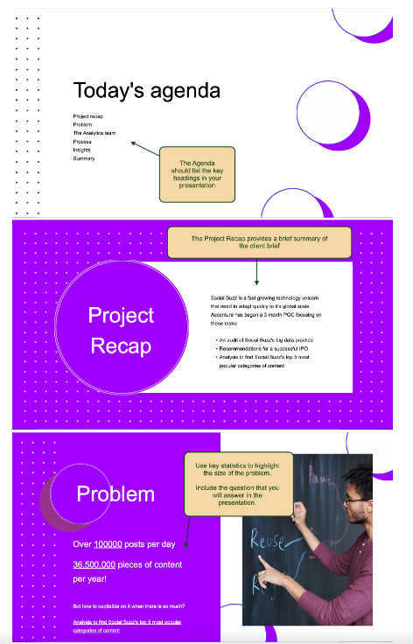

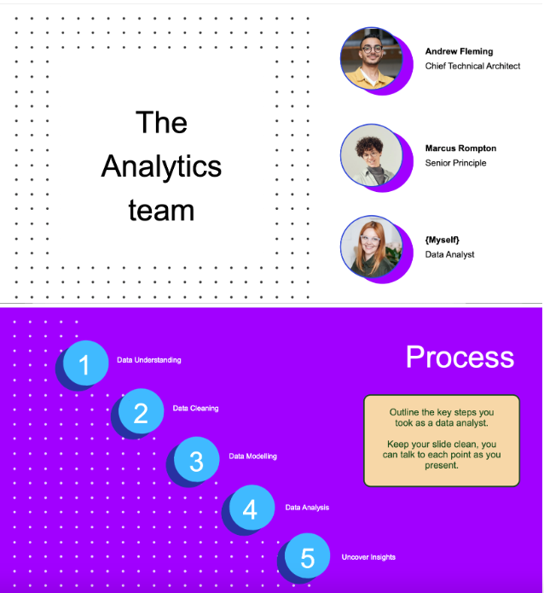

**Create your charts**

The final step of this task is**to populate slides 7 - 10 with your data insights.**

If you’ve lost your spreadsheet, we’ve attached one here again for you to use.

LINK : CLEAN EXCEL FILE (With Proper Data) for visualization

We know that the client wants to understand the top 5 content categories. Have a think about what are the best ways to present this? In a pie chart? In a bar chart?

There are also some other interesting insights that we might want to share with them. For example:

* How many unique categories are there?
* How many reactions are there to the most popular category?
* What was the month with the most posts?

If you get stuck, [here](https://www.excel-easy.com/data-analysis/charts.html) is a resource on how to make charts in excel.

**Once your slides are complete with your data insights and charts, upload your work to see the example answer in the next step.**

PPT Submission Link

**Data Visualization Explained**

Nice work completing the data visualization exercise!

Like we’ve said, it’s important to keep your presentation simple and clean - **take a look at the annotated example images** to see how you could have visualized the data.

You could have done it differently, and that’s okay! There are lots of different ways that you can bring data to life.

Now let’s go to your final step where you will practice your presentation skills!

Click on each image to expand: output images for verification

**TASK4**

**Task 4: Present to the Client**

**Presentation tips**

When presenting to the client there are a few things that you should remember:

1. They may not all be familiar with data, so you need to make sure you talk to them in business-friendly language.
2. You want to show them that you’ve understood their business and requirements, so use their terminology and language relevant to the task.
3. This is your time to shine and to show them how great you are! Try to present your work with confidence and conviction, if you don’t feel confident talking about your results then it’s a good indication that you don’t understand them fully or may need to revisit the dataset! Speaking about your results should feel natural when you explain what you’ve done.
4. A good presentation always takes a lot of preparation. The more you practice presenting your content, the more confident you will be when the time comes. Practice with your housemates, friends, family, anyone that is free! Ask for feedback and keep improving until you’re happy with your presentation and you’re confident in presenting your content.

Let’s keep going, you’re nearly finished!

**Record your video**

It is now time to record your presentation to the client.

Remember, your presentation should be concise, engaging and should tell a compelling story. It should be no longer than 10 minutes.

Recording the video may require a few attempts until you’re happy with it, but this task shouldn't take you longer than 30 minutes.

While the recording functionality in this task won't allow you to share your slides as you speak, it will help you learn how to communicate and use eye contact when presenting.

Let's record below!

**Finish Line: Collect achievements**

* **Resume Snippet**
* Interview Tip

Resume Snippet

Take your updated resume and apply for Opportunities .

**Accenture North America Data Analytics and Visualization Job Simulation on Forage - January 2024**

* Completed a simulation focused on advising a hypothetical social media client as a Data Analyst at Accenture
* Cleaned, modelled and analyzed 7 datasets to uncover insights into content trends to inform strategic decisions
* Prepared a PowerPoint deck and video presentation to communicate key insights for the client and internal stakeholders

*Use our*[*resume guidance here*](https://www.canva.com/design/DAFl7ChBdDM/MXZ3Zt4NE0vnUssENp5E3g/view?utm_content=DAFl7ChBdDM&utm_campaign=designshare&utm_medium=link2&utm_source=uniquelinks&utlId=GI3o8IbcOQ#1)

**Accenture North America Data Analytics and Visualization Job Simulation on Forage - January 2024**

* Completed a simulation focused on advising a hypothetical social media client as a Data Analyst at Accenture
* Cleaned, modelled and analyzed 7 datasets to uncover insights into content trends to inform strategic decisions
* Prepared a PowerPoint deck and video presentation to communicate key insights for the client and internal stakeholders

# Interview Tip

In a typical interview you’ll be asked “why are you interested in this role?” or “why are you interested in working at our company?”. Use this interview tip to explain why you want the job.

## “Why are you interested in this role?”

I recently participated in Accenture’s Data Analytics & Visualization job simulation on the Forage platform, and it was incredibly useful to understand what it might be like to participate in a typical project team at Accenture, and to use Excel and data analytics and visualization skills in a realistic context.

Through this program I realized that I really enjoy cleaning, modelling and analyzing client data, creating slides to communicate findings and presenting insights back to the client. I would love to apply what I've learned in a diverse project team at a company like Accenture.

**“Why are you interested in this role?”**

I recently participated in Accenture’s Data Analytics & Visualization job simulation on the Forage platform, and it was incredibly useful to understand what it might be like to participate in a typical project team at Accenture, and to use Excel and data analytics and visualization skills in a realistic context.

Through this program I realized that I really enjoy cleaning, modelling and analyzing client data, creating slides to communicate findings and presenting insights back to the client. I would love to apply what I've learned in a diverse project team at a company like Accenture.

* Before you get your certificate, we have a couple of final questions for you!

Now that I have completed the Accenture Data Analytics Virtual Experience, I have a better understanding of who Accenture is and the work they do.

Strongly DisagreeDisagreeNeutralAgreeStrongly Agree

[Click here](https://www.theforage.com/privacy) to learn how your data is shared.

* Before you get your certificate, we have a couple of final questions for you!

Now that I have completed the Accenture Data Analytics Virtual Experience, I feel more confident about the type of work I would be doing at Accenture.

Strongly DisagreeDisagreeNeutralAgreeStrongly Agree

* Before you get your certificate, we have a couple of final questions for you!

Now that I have completed the Accenture Data Analytics Virtual Experience, I am more likely to apply for a role with Accenture.

Strongly DisagreeDisagreeNeutralAgreeStrongly Agree

* Before you get your certificate, we have a couple of final questions for you!

Completing the Accenture Data Analytics Virtual Experience has developed my practical skills.

Strongly DisagreeDisagreeNeutralAgreeStrongly Agree

How would you rate your program experience?













What did you like about the program? (Optional)

*Your answer might be featured in Accenture North America’s Virtual Experience homepage.*



What can we improve? (Optional)

*Your answer will only be seen by Forage to help improve the program for future students.*



One last thing to make you stand out!

Would you like to express your interest in working at Accenture North America



Yes, I'd love to!



No, I'm not interested.

LOGIN: https://www.theforage.com/login

Explanation:

Slide 1: Introduction "Good [morning/afternoon/evening] everyone. Today, I'm thrilled to present the insights we've gathered during our engagement with Social Buzz, a dynamic player in the social media and content creation space."

Slide 2: Project Engagement Objectives "Our journey with Social Buzz started with the shared goals of overcoming scaling challenges, tackling unstructured data complexity, and preparing for an imminent IPO. The aim was clear: to leverage external expertise for effective scaling and adopt best practices in their data-driven landscape."

Slide 3: Project Overview "In the next few minutes, we'll delve into the specifics of our engagement, focusing on the audit of big data practices, recommendations for a successful IPO, and an analysis of the top 5 content categories. Let's explore the key findings."

Slide 4: Unique Categories and Popular Reactions "We identified a total of 16 unique content categories within Social Buzz. Notably, the 'Animal' category emerged as the most popular, boasting 1897 posts and the highest aggregate of reactions. The month of January saw the highest posting activity."

Slide 5: Popularity Insights "Visualizing the data, the Top 5 Categories based on reaction scores showcased a diverse range of interests. Animals, in particular, stood out as the favorite among users. Understanding these preferences can guide content strategy and user engagement."

Slide 6: Sentiment Analysis "Our sentiment analysis revealed some fascinating insights. Positive sentiment dominates at 56%, indicating an optimistic and favorable user environment. Negative sentiment at 31% and neutral at 13% provide valuable context for understanding user interactions."

Slide 7: Comment Types Breakdown "Moving on to comment types, 'photo' comments took the lead in terms of count, suggesting that users actively engage through visual content. Video comments closely followed, with GIF and audio comments showing comparable engagement."

Slide 8: IPO Preparation Recommendations "As Social Buzz ventures into the IPO realm, we've outlined recommendations based on industry best practices. This includes a detailed overview of the IPO preparation process to ensure a smooth and successful transition to the public market."

Slide 9: Technology Landscape Workshop "Our deep dive into Social Buzz's technology landscape included stress testing to identify weak spots. Insights gained from our technology architecture workshop with the Data Team will be pivotal in optimizing their systems for future scalability."

Slide 10: Conclusion and Business Insights "In conclusion, the data-driven insights presented today provide a roadmap for Social Buzz's future growth. We've highlighted key findings, offered IPO preparation guidance, and identified areas for improvement. Now, I invite any questions or discussions you may have."